**Sales Rep App User Requirements**

* User is expected to be able to view the Sales Analysis Report
* User is expected to be able to view the Customer Item Sales Analysis Report
* Provisions must be made for user to remove items for Customers’ Standing orders
* Provisions must be made for user to view customer standing orders
* Provisions must be made for user to adjust the amount of items on a Customers’ Standing Orders
* User is expected to be able to add items to the list of items
* User is expected to be able to remove items from the list of items

**Sales Rep System requirements**

* User Log in
  + Application must allow User to log in with their username and password
  + Application must validate user name and password against entries saved in database
* User Log Off
  + Application must allow the User with the option to log out
* Navigation
  + Application must allow the user with a method of navigation to go back to the previous screen
  + Application must allow the user with a method of navigation to go back to the home screen
* Home Screen Options
  + Application must allow the user the option to go to item list
  + Application must allow the user the option to go to standing orders
  + Application must allow the user the option to go to reports
* Item list Options
  + Application must allow the user to view the item list
  + Application must allow the user to add an item to the list
  + Application must allow the user to remove an item from the list
* Reports Options
  + Application must allow the user to view Customer Sales Analysis Report
  + Application must allow the user to view Item Sales Analysis Report
* Standing Orders Options
  + Application must allow the user to view customer standing orders
  + Application must allow the user to edit customer standing orders
* Adding item to list
  + Application must accept input from user when adding an item to the list
* Removing item from the list
  + Application must allow the user to search for an item that is to be removed
  + Application must accept user input when user wishes to search
* Editing customer standing orders
  + Application must allow the user to search for a customer standing order they wish the edit
  + Application must accept user input when user wishes to search for customer standing order

**Sales Rep Use Cases**

|  |  |  |  |
| --- | --- | --- | --- |
| Use Case Number | | 1 | |
| Use Case Name | | Change Customer Standing Order | |
| Related Requirements | | Customer number, Standing Order number | |
| Goal in Context | | Change Customer Standing Order to a more suitable order | |
| Pre-Condition | | Customer must have existing standing order | |
| Successful End Condition | | User changed standing order successfully | |
| Fail End Condition | | User unable to change standing order | |
| Primary Actors | | Sales Representative | |
| Secondary Actors | |  | |
| Trigger | | Returns are over 10% | |
| Main Flow | Step | | Action |
|  | 1 | | User logs into application |
|  | 2 | | Selects Standing Orders Option |
|  | 3 | | Selects Edit Standing Order |
|  | 4 | | Searches for standing order to edit by entering information about standing order |
|  | 5 | | Selects standing order from list returned |
|  | 6 | | Makes changes to standing order |
|  | 7 | | Saves changes by selecting save |

|  |  |  |  |
| --- | --- | --- | --- |
| Use Case Number | | 2 | |
| Use Case Name | | Add item to list | |
| Related Requirements | | Item name, Item number | |
| Goal in Context | | To change out underselling products with selling products | |
| Pre-Condition | | Item must not already exist | |
| Successful End Condition | | User updates item list successfully | |
| Fail End Condition | | User unable to update item list | |
| Primary Actors | | Sales Representative | |
| Secondary Actors | |  | |
| Trigger | | There is a new item that is for sale | |
| Main Flow | Step | | Action |
|  | 1 | | User logs into application |
|  | 2 | | User selects Item list option |
|  | 3 | | User selects add item option |
|  | 4 | | User enters the item information |
|  | 5 | | User presses add item button |

|  |  |  |  |
| --- | --- | --- | --- |
| Use Case Number | | 3 | |
| Use Case Name | | Remove item from list | |
| Related Requirements | | Item number, Item name | |
| Goal in Context | | To remove an item from the item list | |
| Pre-Condition | | Item must already exist | |
| Successful End Condition | | Item was successfully removed | |
| Fail End Condition | | Item was not successfully removed | |
| Primary Actors | | Sales Rep | |
| Secondary Actors | |  | |
| Trigger | | Item Sales low | |
| Main Flow | Step | | Action |
|  |  | | User logs into application |
|  |  | | User selects item list |
|  |  | | User selects remove item |
|  |  | | User searches for item to be removed by entering the item information |
|  |  | | User selects the item from list returned |
|  |  | | User selects remove |

|  |  |  |  |
| --- | --- | --- | --- |
| Use Case Number | | 4 | |
| Use Case Name | | View Reports | |
| Related Requirements | | Report Name | |
| Goal in Context | | To view a report | |
| Pre-Condition | | Report must be up to date | |
| Successful End Condition | | Successful viewing of report | |
| Fail End Condition | | Unsuccessful viewing of report | |
| Primary Actors | | Sales Rep | |
| Secondary Actors | |  | |
| Trigger | |  | |
| Main Flow | Step | | Action |
|  | 1 | | User logs into application |
|  | 2 | | User selects reports |
|  | 3 | | User selects the report that is needed to be viewed |
|  | 4 | | User views report |

|  |  |  |  |
| --- | --- | --- | --- |
| Use Case Number | | 5 | |
| Use Case Name | | Log in | |
| Related Requirements | | Username, Password | |
| Goal in Context | | Log into application | |
| Pre-Condition | | Application installed on device | |
| Successful End Condition | | Successful log in | |
| Fail End Condition | | Unsuccessful log in | |
| Primary Actors | | Sales Representative | |
| Secondary Actors | |  | |
| Trigger | | Incorrect username or password | |
| Main Flow | Step | | Action |
|  | 1 | | Users opens application |
|  | 2 | | User Enters username and password |
|  | 3 | | User proceeds to log in |

|  |  |  |  |
| --- | --- | --- | --- |
| Use Case Number | | 6 | |
| Use Case Name | | Log out | |
| Related Requirements | |  | |
| Goal in Context | | Log out of application | |
| Pre-Condition | | Currently logged into application | |
| Successful End Condition | | Successful log out | |
| Fail End Condition | | Unsuccessful log out | |
| Primary Actors | | Sales Representative | |
| Secondary Actors | |  | |
| Trigger | |  | |
| Main Flow | Step | | Action |
|  | 1 | | User selects log out option |
|  | 2 | | User awaits successful log out |

**Activity Diagrams**





**Data Flow Diagram**



Sales Rep Application User Interface

Fig 1- Log On Screen

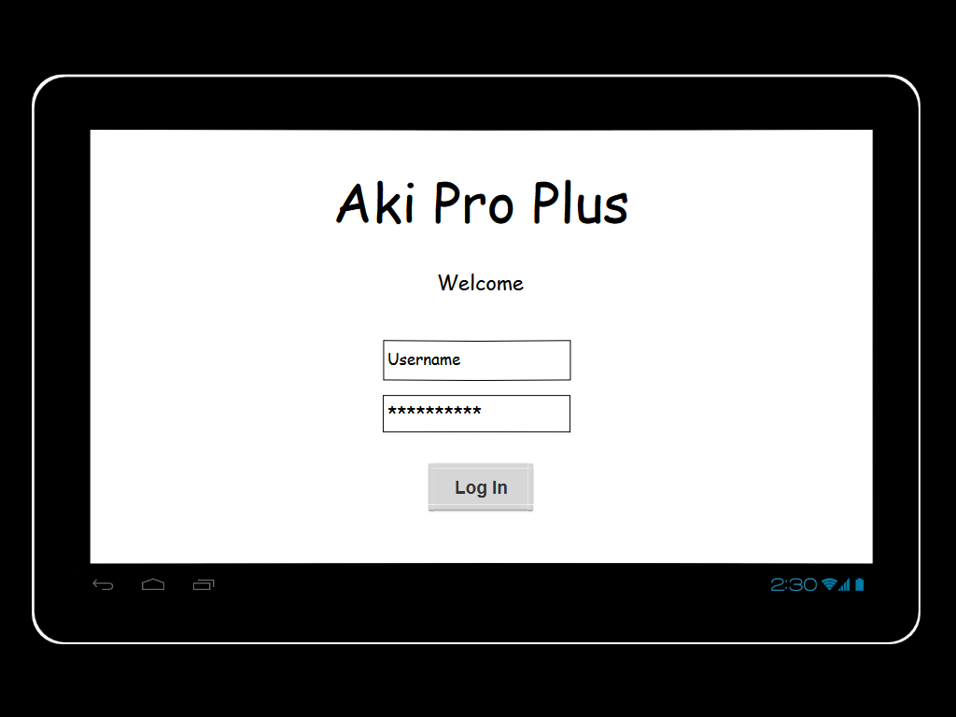

Fig 2- Home Screen

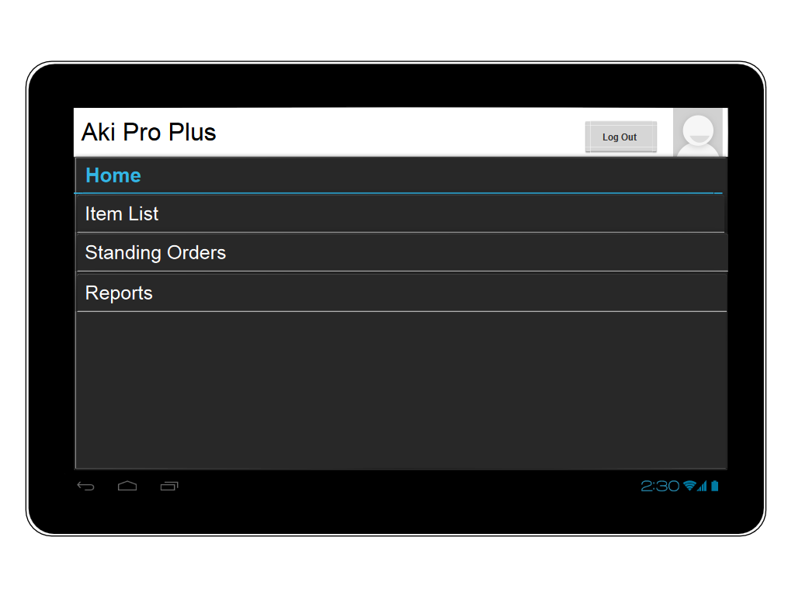

Fig 3- Item List Screen

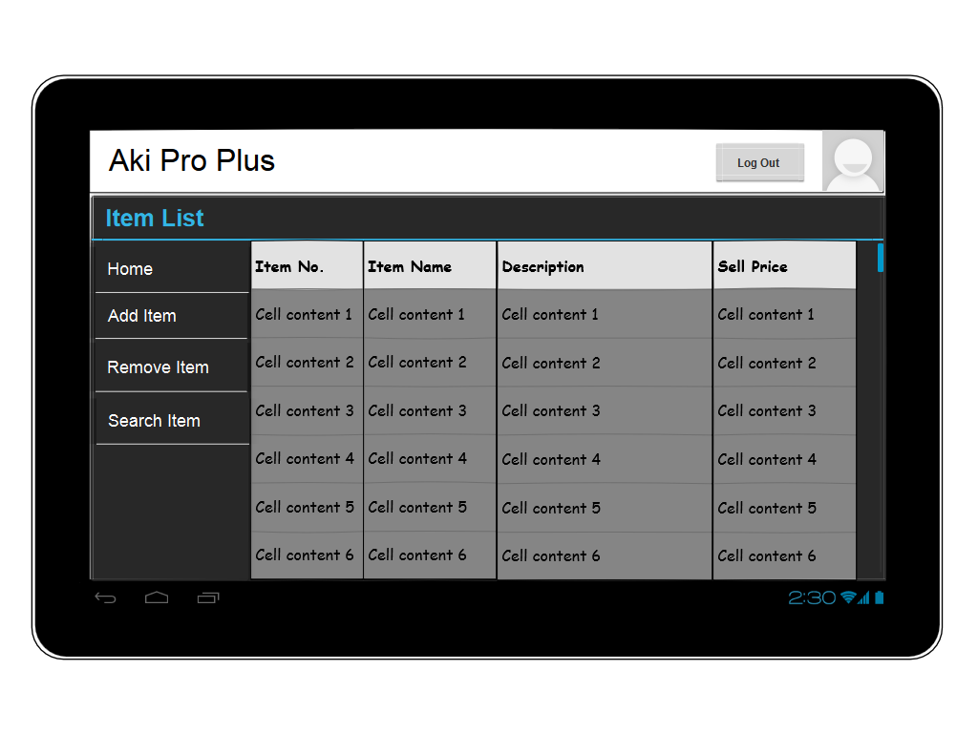

Fig 4- Add Item

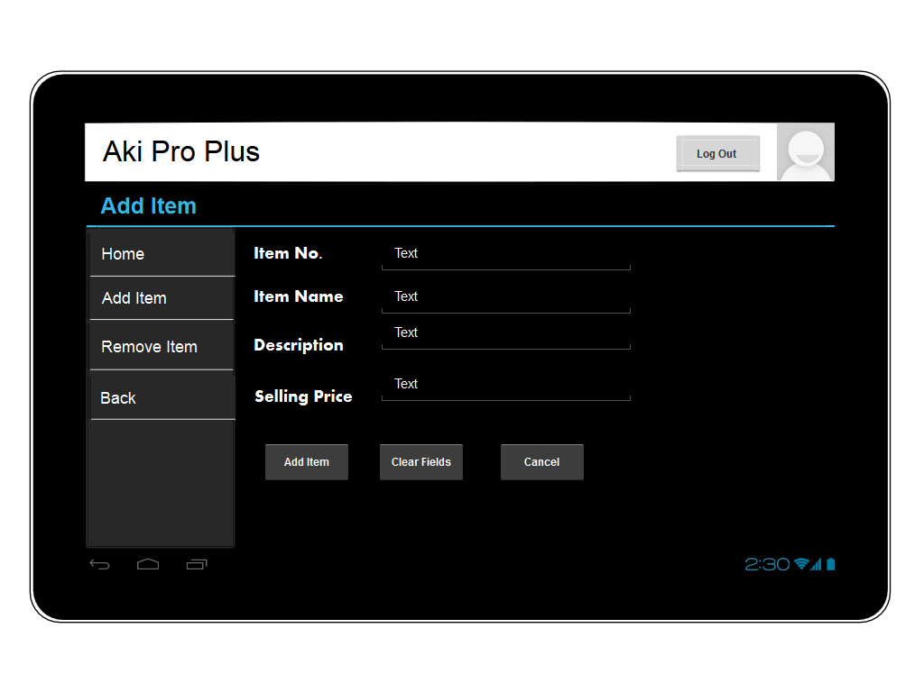

Fig 5- Remove Item

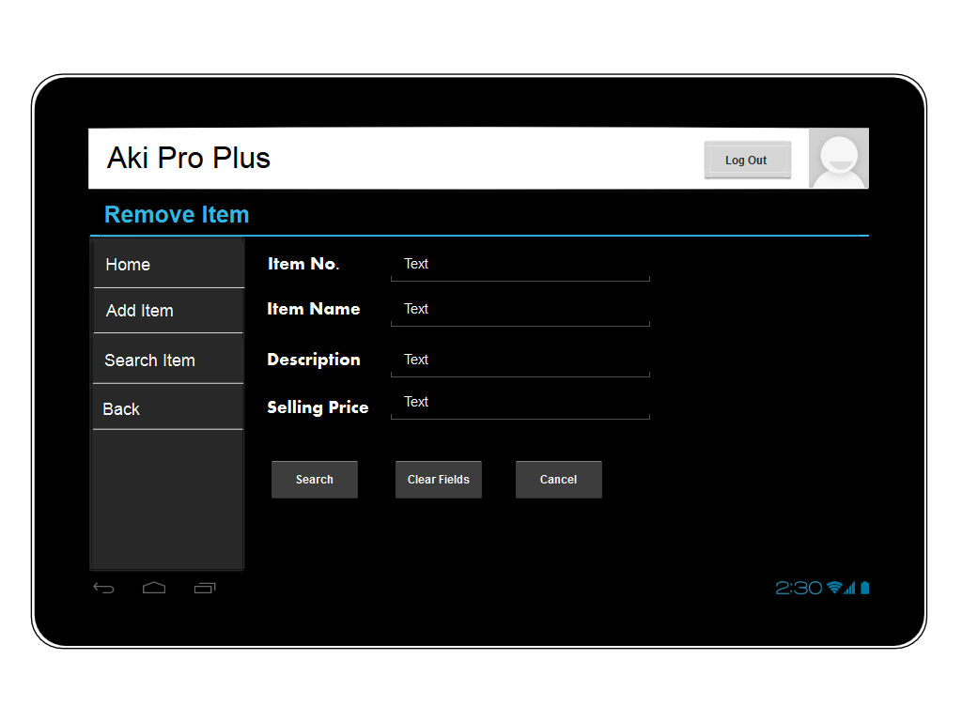

Fig 6- Remove Item (After Search)

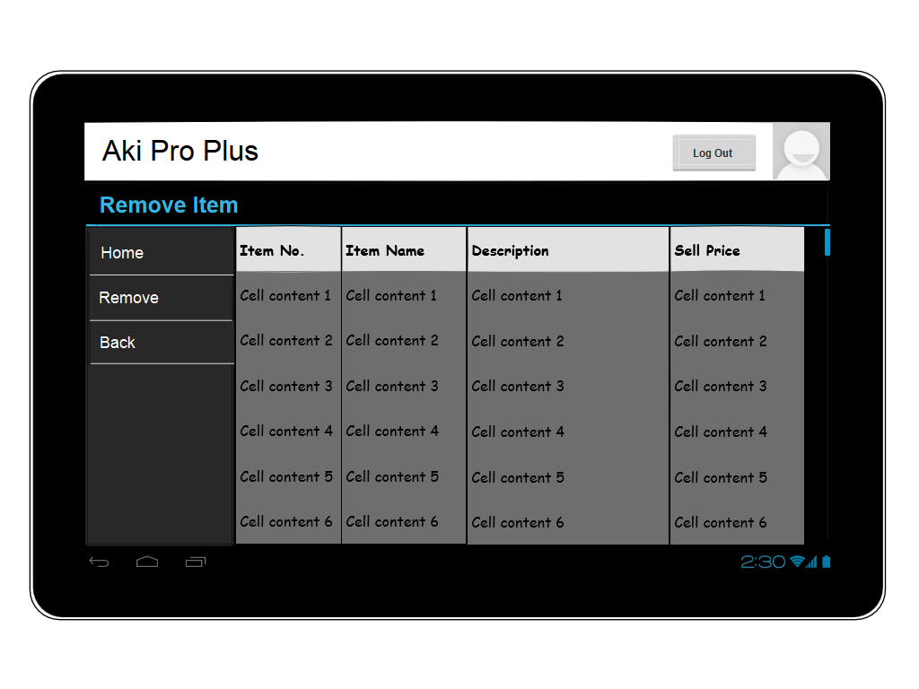

Fig 7- Reports Screen

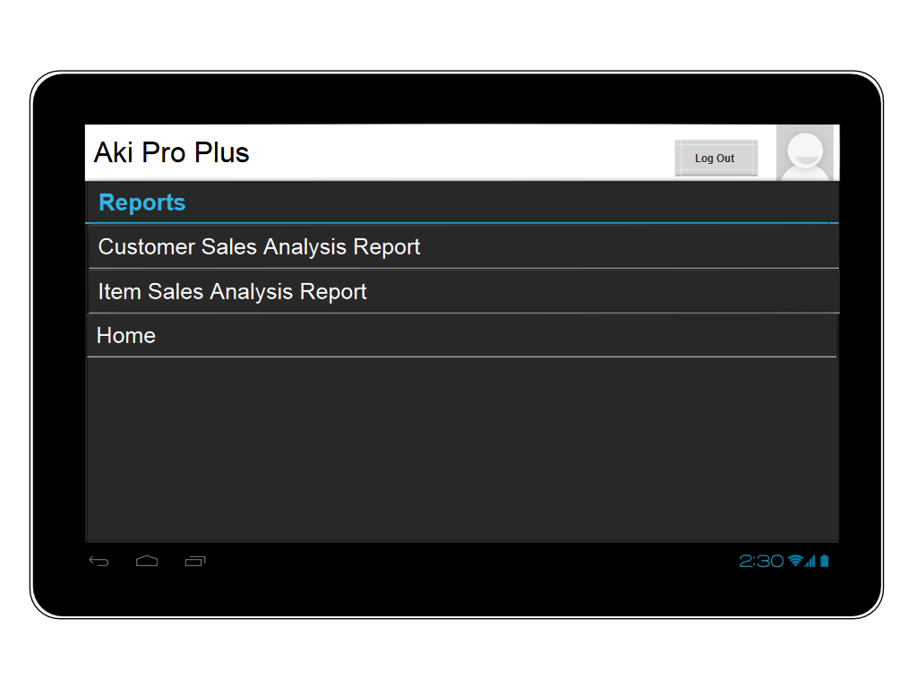

Fig 8- Standing Orders Screen

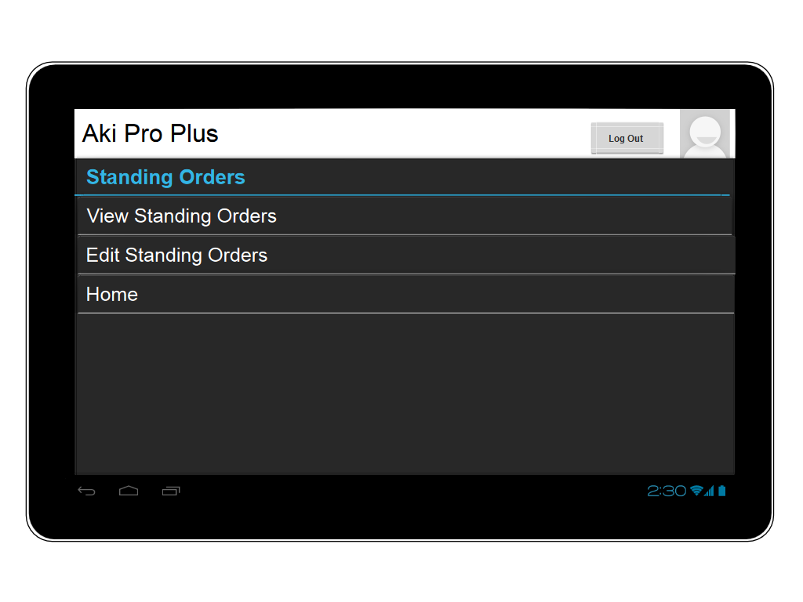

Fig 9- Edit Standing Order

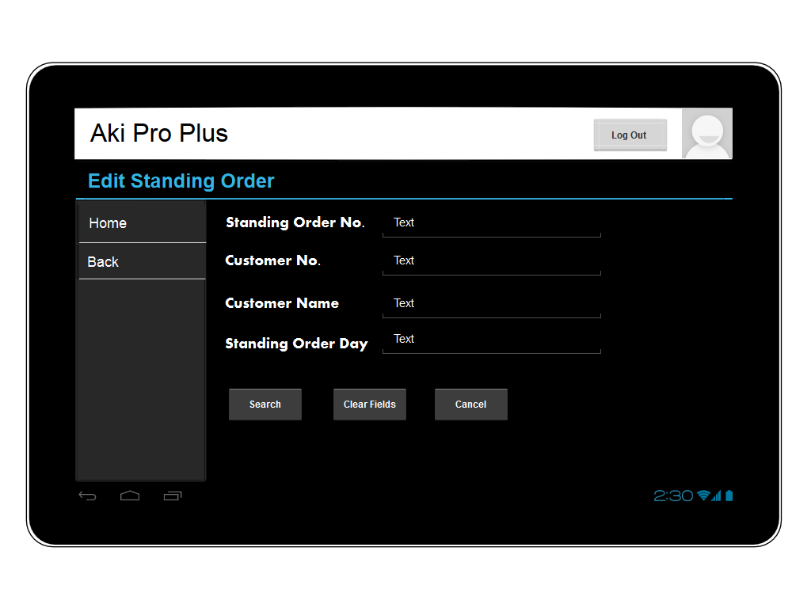

Fig 10- Edit Standing Order (After Search)

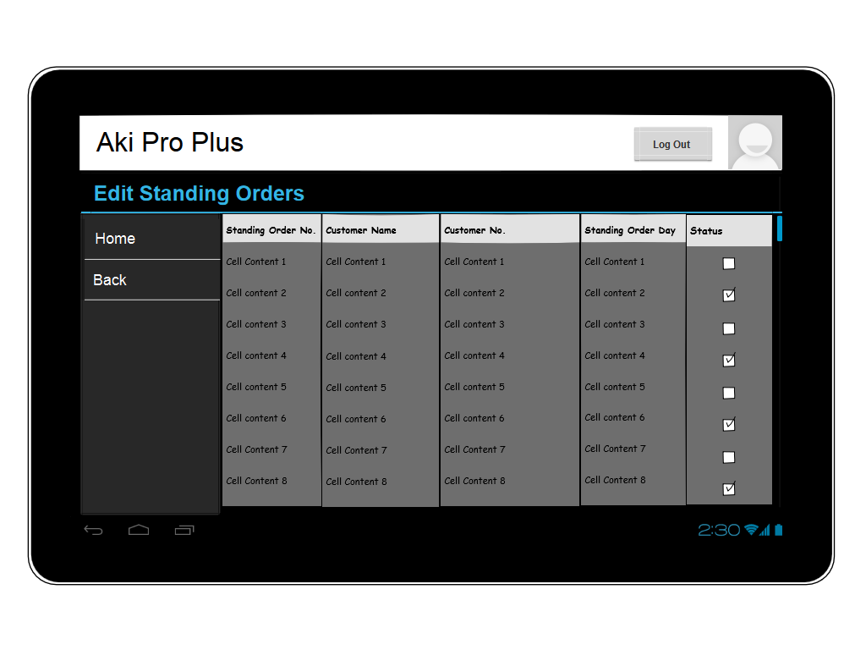

Fig 11- Edit Standing Order (After Selecting a Standing Order)

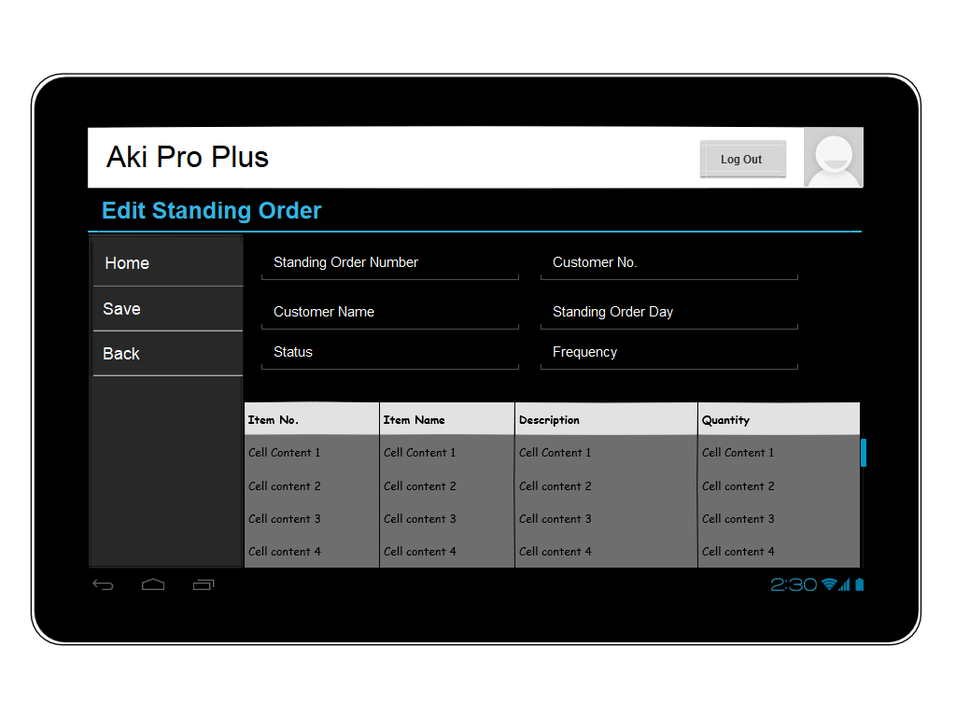

Fig 12- View Standing Order

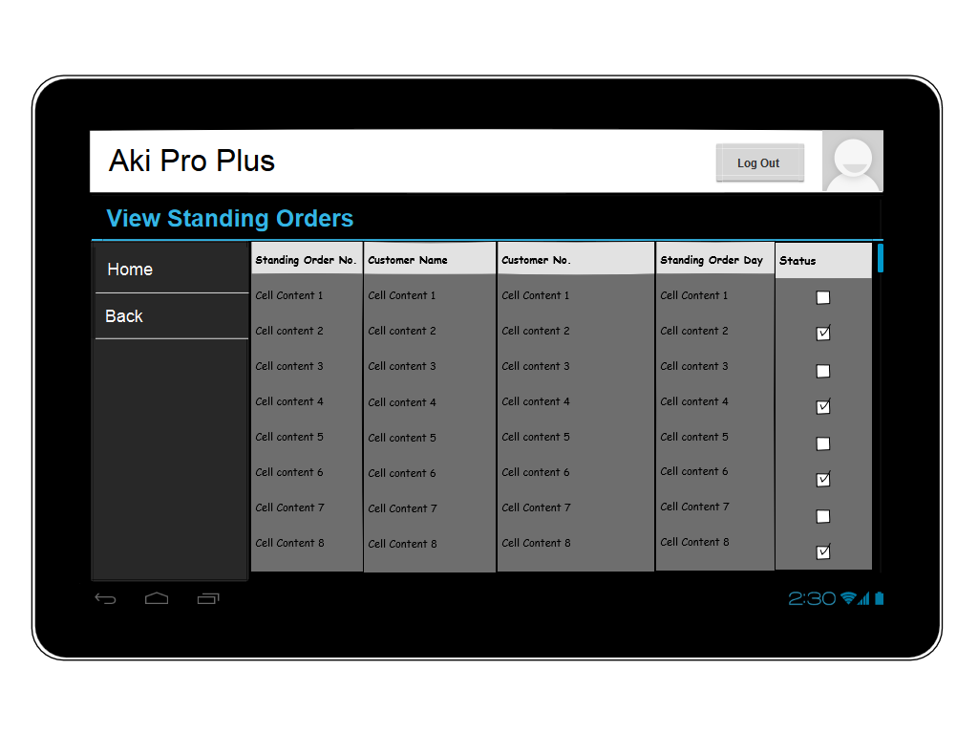

Fig 13- View Standing Order (After Selecting a Standing Order)

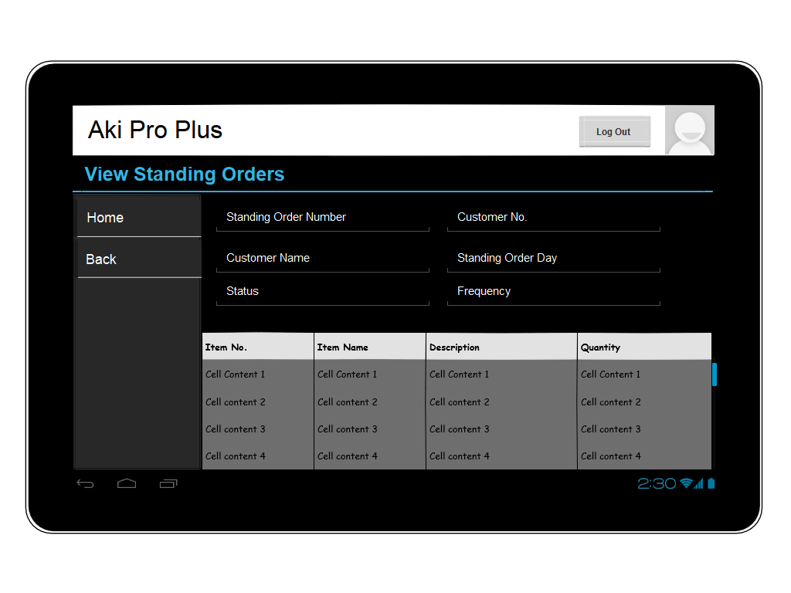

Sequence Diagrams





Resource Tables

Modify Standing Orders

|  |  |  |  |
| --- | --- | --- | --- |
| Action | Parameters | Output | Description |
| GET | Standing Order No./Customer No./Token | {Standing Order No., Customer No., Customer Name, Order Day, Status, Frequency} | A list of standing orders for customers returned |
| POST | Operation/token/data | A JSon object | Operation= ‘change date’, ‘change item’ , ’change quantity’ , ’change frequency’ , ’change status’ |